# **Requirement Specification Document (RSD)**

# **Application Name: RevieveMyRide.com**

Table of Contents

1. Introduction: 1

1.1 Purpose: 1

1.2 Overview 1

1.3 Project Scope: 1

1.4 Business Objectives: 2

2. General Description 2

2.1 Product Functions: 2

2.2 Similar System Information: 2

2.3 User Characteristics: 2

2.4 User Problem Statement: 2

2.5 User Objectives: 3

2.6 General Constraints: 3

3. Functional Requirements: 3

3.1 User Registration and Profile Management: 3

3.2 Posting and Listing Car Parts for Sale: 3

3.3 Search and Filtering Capabilities: 3

3.4 Online Purchase Functionality: 3

3.5 Subscription System: 3

3.6 Notifications and Alerts: 4

3.7 User Feedback and Rating System: 4

3.8 Admin Panel for Content Moderation: 4

4. Interface Requirements: 4

4.1 User Interfaces: 4

4.2 Hardware Interfaces: 4

4.3 Communications Interfaces: 4

4.4 Software Interfaces: 5

5. Other Requirement: 5

5.1 Data Requirements: 5

5.2 Security Requirements: 5

5.3 Performance Requirements: 5

5.4 Testing and Quality Assurance: 5

5.5 Deployment and Release: 5

5.6 Maintenance and Support: 5

5.7 Legal and Compliance Requirements: 6

5.7 User Documentation: 6

5.8 Performance Monitoring: 6

5.9 Backup and Disaster Recovery: 6

5.10 Compliance with Accessibility Standards: 6

5.11 Integration with Third-Party Services: 6

5.12 Documentation and Reporting: 6

5.13 User Training: 7

5.14 System Architecture: 7

6. Non-Functional Requirements: 7

6.1 Platform Compatibility: 7

6.2 User Interface and User Experience: 7

6.3 Security: 7

6.4 Scalability: 7

6.5 Search Engine Optimization (SEO) Considerations: 7

6.6 Technical Stack Preferences: 8

7. Preliminary Use Case Models and Sequence Diagrams: 9

7.1 Use Case 9

7.2 Sequence Diagram 10

8. Project Timeline: 10

9. Change Management: 12

10. Acceptance Criteria: 12

11. Sign-Off: 12

# 1. Introduction:

## 1.1 Purpose:

This document outlines the detailed requirements for the development of an Automotive Parts Marketplace Software Application for Clarkton Corporation, as specified in the RFP by DevelopX Company Ltd.

## 1.2 Overview

DevelopX Company Ltd's Request for Proposal (RFP) outlines a plan to develop an Automotive Parts Marketplace Software Application for Clarkton Corporation. The proposal includes details about the application's features, technical specifications, budget, and timeline. DevelopX emphasizes their commitment to innovation, user-friendly design, secure payment processing, and scalability. The proposal aims to create a comprehensive platform for buying and selling junked car parts efficiently and transparently.

## 1.3 Project Scope:

The project aims to develop a comprehensive Automotive Parts Marketplace Software Application. The application will facilitate the buying and selling of automotive parts and accessories, connecting sellers directly with buyers. Key features include user registration, part listings, search functionality, secure payment processing, subscription system, user ratings, and an admin panel.

## 1.4 Business Objectives:

* Provide a platform for buyers and sellers of automotive parts to connect directly.
* Reduce waste of automotive parts by promoting their reuse.
* Enhance the user experience with a user-friendly interface.
* Facilitate secure and efficient transactions.

# 2. General Description

## 2.1 Product Functions:

The Automotive Parts Marketplace Software Application by DevelopX for Clarkton Corporation enables users to register, post, and find junked car parts easily. It includes secure transactions, notifications, user feedback, and an admin panel for efficient management.

## 2.2 Similar System Information:

The system excels with its unique Excel import/export feature, setting it apart from other platforms.

## 2.3 User Characteristics:

Users, both sellers, and buyers, require basic computer skills. Sellers provide detailed part descriptions, while buyers search for specific car components.

## 2.4 User Problem Statement:

Current methods lack efficiency, involving intermediaries and higher costs. Sellers lack a platform, and buyers struggle to find specific car parts at reasonable prices.

## 2.5 User Objectives:

Users aim for efficient listing and finding of parts, secure transactions, and a user-friendly experience for seamless interactions.

## 2.6 General Constraints:

The system ensures an intuitive interface, compatibility across platforms (Windows, Mac, Android, iOS), secure development tools (React, NodeJS, MongoDB), data security compliance, scalability, and continuous post-launch support.

# 3. Functional Requirements:

## 3.1 User Registration and Profile Management:

* Users can register with email or via third-party accounts (Google, Apple, Facebook).
* Users can provide additional profile information.

## 3.2 Posting and Listing Car Parts for Sale:

* Sellers must upload at least three photos and a description for each part.
* Sellers must specify an intended price for each listed part.
* Buyers can post need requests for specific car parts.
* Buyers can communicate directly with sellers on the platform.

## 3.3 Search and Filtering Capabilities:

* Search by keywords.
* Filters based on distance, production year, price, and mailing options.

## 3.4 Online Purchase Functionality:

* Buyers can purchase items securely using credit cards.
* Sellers receive payments through a secure payment gateway.

## 3.5 Subscription System:

* No subscription fees for buyers and sellers.
* A fee (5% of the deal amount) is charged to sellers after a successful deal.

## 3.6 Notifications and Alerts:

* Instant messaging for user communication.
* Push notifications for mobile users.
* Email notifications for web users.

## 3.7 User Feedback and Rating System:

* Users can rate and write comments about each other.
* User profiles display overall ratings and links to comments.

## 3.8 Admin Panel for Content Moderation:

* Real-time and historical statistics for Clarkton Corporation.
* Ability to add custom data to the admin panel.

# 4. Interface Requirements:

## 4.1 User Interfaces:

The user interface of the Automotive Parts Marketplace Software Application offers an intuitive and visually appealing design. It includes interactive elements, such as search bars, filters, and messaging features, ensuring a seamless experience for both buyers and sellers. The interface is designed for desktop browsers, mobile devices (Android and iOS), and tablets, providing consistent usability across various platforms.

## 4.2 Hardware Interfaces:

The application is designed to operate on standard computer hardware with internet connectivity. It is compatible with devices such as desktop computers, laptops, smartphones, and tablets. There are no specific hardware requirements, ensuring accessibility for a wide range of users with different devices and configurations.

## 4.3 Communications Interfaces:

The software facilitates communication between users through real-time messaging features and email notifications. It utilizes standard internet communication protocols, ensuring secure data transmission between buyers, sellers, and the platform's servers. The messaging system allows users to communicate instantly, enabling smooth interactions and negotiations during the buying and selling process.

## 4.4 Software Interfaces:

The application integrates with various software components to enhance functionality. It utilizes React.js for the frontend, NodeJS for the backend, and MongoDB as the non-relational database. Payment processing is handled through Stripe, a popular and secure payment gateway. The software interfaces seamlessly with these technologies, ensuring robust performance, data security, and reliable payment processing for users. Additionally, the application is hosted on the AWS cloud platform, ensuring scalability and high availability.

# 5. Other Requirement:

## 5.1 Data Requirements:

* Structured database schema for efficient data storage and retrieval.
* Secure data storage using modern encryption methods.

## 5.2 Security Requirements:

* Third-party secure user authentication procedures.
* Compliance with data protection regulations.
* Adherence to data security and privacy standards.

## 5.3 Performance Requirements:

* Optimization for speed and performance.
* High-pressure testing to ensure smooth user experience.

## 5.4 Testing and Quality Assurance:

* Extensive quality assurance procedures.
* Quick resolution of identified issues.
* Continuous monitoring and updates.

## 5.5 Deployment and Release:

* Deployment planned for the last week of November.
* Continuous support and maintenance post-launch.

## 5.6 Maintenance and Support:

* Ongoing maintenance to keep the application up-to-date.
* Helpdesk and support services.
* Regular updates and enhancements.

This abbreviated Requirement Specification Document provides an overview of the key requirements and specifications for the Automotive Parts Marketplace Software Application for Clarkton Corporation. Depending on the specific needs of the project, this document can be expanded to include more detailed information and technical specifications.

## 5.7 Legal and Compliance Requirements:

* Compliance with applicable data protection and privacy laws (e.g., GDPR, CCPA).
* Transparency in the use of AI and adherence to ethical AI principles.
* Acknowledgement of intellectual property rights and data ownership.
* Non-disclosure agreement for sensitive project-related information.
* Resolving disputes in accordance with the terms specified in the contract.

## 5.7 User Documentation:

* Comprehensive user documentation and help resources.
* Tutorials and guides for users to navigate the platform effectively.

## 5.8 Performance Monitoring:

* Continuous monitoring of system performance.
* Real-time error detection and resolution.

## 5.9 Backup and Disaster Recovery:

* Regular data backups to ensure data recovery in case of failures.
* Disaster recovery plan in place for minimizing downtime.

## 5.10 Compliance with Accessibility Standards:

* Ensure that the platform is accessible to users with disabilities.
* Compliance with WCAG (Web Content Accessibility Guidelines).

## 5.11 Integration with Third-Party Services:

* Integration with payment gateways, such as Stripe and PayPal.
* Integration with other relevant third-party services as needed.

## 5.12 Documentation and Reporting:

* Detailed project documentation, including technical specifications.
* Regular reporting on project progress, issues, and resolutions.

## 5.13 User Training:

* Provision of user training and onboarding materials.
* Support for users to effectively utilize the platform.

## 5.14 System Architecture:

* Microservices architecture for the backend.
* MongoDb database
* Integration with payment gateways like Stripe.
* Version control using GIT.
* Client-side built with React.js.
* Responsive design using Bootstrap.
* Utilise Kubernetes for scaling.

# 6. Non-Functional Requirements:

## 6.1 Platform Compatibility:

* Android and iOS mobile applications.
* Web application compatible with modern browsers.

## 6.2 User Interface and User Experience:

* Intuitive, user-friendly interface.
* Responsive design for both web and mobile.

## 6.3 Security:

* Secure user authentication and data protection.
* Payment processing using Visa and MasterCard.

## 6.4 Scalability:

* Horizontally scalable database system for high-volume user activities.
* Redundancy and backup mechanisms to ensure system availability.

## 6.5 Search Engine Optimization (SEO) Considerations:

* Optimize for performance and loading speed.
* Implement strong security measures.
* Ensure high-quality, relevant content.
* Regular updates to maintain SEO rankings.

## 6.6 Technical Stack Preferences:

* Development using React and JavaScript.
* Database: mongoDB.
* RESTful APIs for communication.
* Containerization with Docker and orchestration with Kubernetes for scalability.
* Hosting on AWS EC2.

# 7. Preliminary Use Case Models and Sequence Diagrams:

## 7.1 Use Case

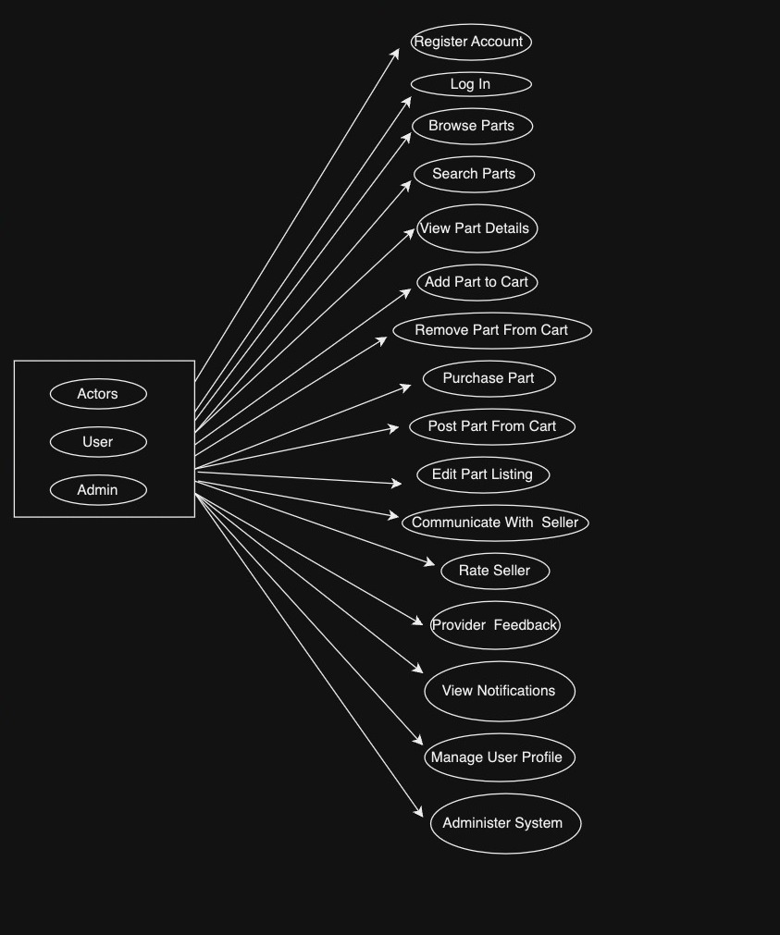

## 7.2 Sequence Diagram

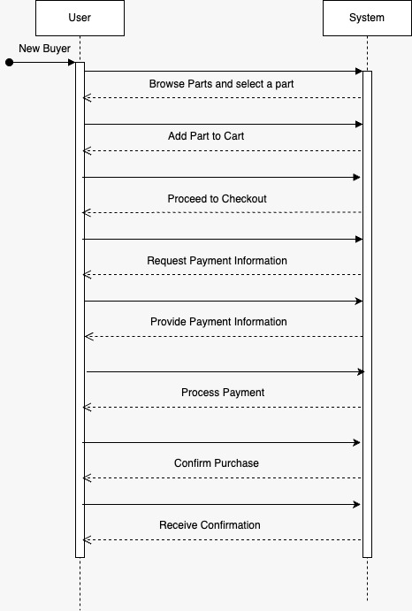

# 8. Project Timeline:

* + - * The project will be completed and delivered by November last week.

Weeks 1-2: Project Planning

* Week 1:
* Define the project goals and scope.
* Set up project tools
* Week 2:
* Brainstorm features and prioritize.
* Create a rough project timeline.
* Assign team roles.

Weeks 3-4: Design and Wireframing

* Week 3:
* Create basic wireframes and layouts.
* Decide on a colour scheme and fonts.
* Week 4:
* Finalize wireframes.
* Create a simple design prototype.

Weeks 5-8: Development

* Week 5-6:
* Start building the front-end structure.
* Set up the database.
* Week 7-8:
* Develop core features on the front end.
* Implement basic back-end functionality.

Weeks 9-10: Feature Development

* Week 9:
* Continue building front-end features.
* Improve user interface.
* Week 10:
* Develop additional back-end functionality.
* Start basic testing.

Weeks 11-12: Testing and Refinement

* Week 11:
* Thoroughly test the web application.
* Fix any bugs or issues.
* Week 12:
* Optimize performance.
* Make user interface refinements based on feedback.

Weeks 13-14: Final Testing and Launch

* Week 13:
* Conduct user acceptance testing.
* Prepare for deployment.
* Week 14:
* Deploy the web application to the internet.

Throughout the entire 14 weeks we kept the scrum calls wherein we discussed our backlogs, challenges, and code reviews to ensure effective communication and collaboration among team members.

# 9. Change Management:

* A defined process for handling changes or additions to the project scope.
* Change requests should be documented and approved.

# 10. Acceptance Criteria:

* Criteria for project acceptance and approval by Clarkton Corporation.
* User acceptance testing to ensure that the application meets specified requirements.

# 11. Sign-Off:

* Formal acceptance of the RSD by Clarkton Corporation.
* Agreement to proceed with the project based on the outlined requirements.

This document serves as a comprehensive guide for the development of the Automotive Parts Marketplace Software Application for Clarkton Corporation. It encompasses functional and non-functional requirements, legal considerations, performance monitoring, and more, to ensure a successful project outcome.

Please note that this RSD can be further expanded and detailed based on the specific needs and complexity of the project. It is essential to engage with your development team and stakeholders to refine and finalize the requirements before moving forward with the project.